**Data Analytics - Mini Capstone Project**

Driti Singhania (*22112008)*

Siddharth R Bhardwaj (*22112028)*

Ria Ann Bijo (*22112033)*

Sejal Saluja (*22112034)*

**Project Purpose and Goals:**

The Crop Recommendation and Analysis Django project aims to assist farmers in making informed decisions by leveraging various datasets related to soil, temperature, production, price, area, rainfall, yield, season, pesticide, state, and fertiliser. The primary goals are to provide crop recommendations based on the given parameters, analyse historical data trends, and offer insights into optimising agricultural practices for better yields and economic returns.

**How to Run the Project:**

1. Setup Environment:

- Install Python and Django.

- Set up a virtual environment for project isolation.

2. Database Setup: - Run migrations to create the database schema: `python manage.py migrate`.

3. Load Data: - Load datasets into the database using Django management commands or import scripts.

4. Run Server:

- Start the Django development server with `python manage.py runserver`.

5. Access the Application:

- Open a web browser and go to `http://127.0.0.1:8000/data-analysis/data` to access the application.

**Data Analytics Methods Used:**

1. Data Collection - We collected data from secondary sources like various websites including government websites. We saved the data in google drive so that the data could be accessible by each of the group members. The link to the dataset is

<https://drive.google.com/file/d/1aHdcMMFDQZni3w7kP0I5dUKMr3gXNHE_/view?usp=drive_web&authuser=0>

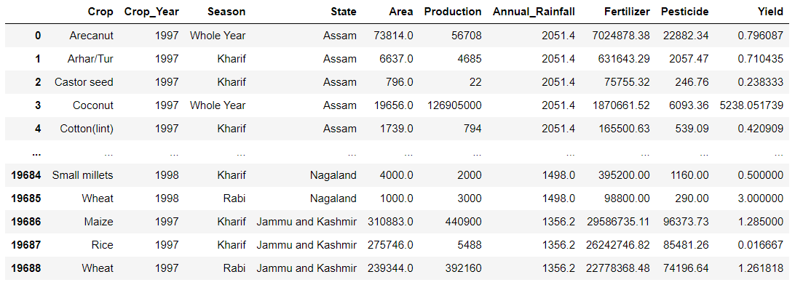

2. Data Cleaning: - Preprocess datasets to handle missing values, outliers, and inconsistencies.

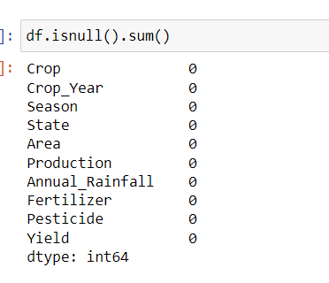

3. Exploratory Data Analysis (EDA):

- Conduct EDA to understand data distributions, correlations, and patterns.

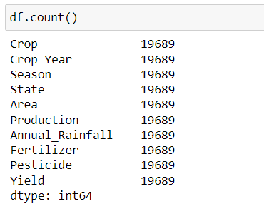

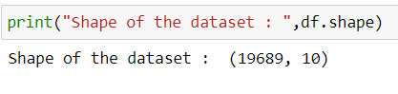

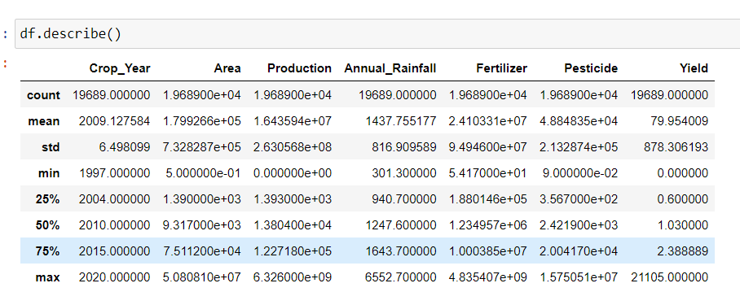

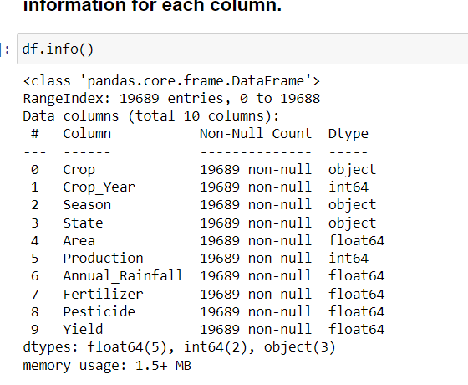

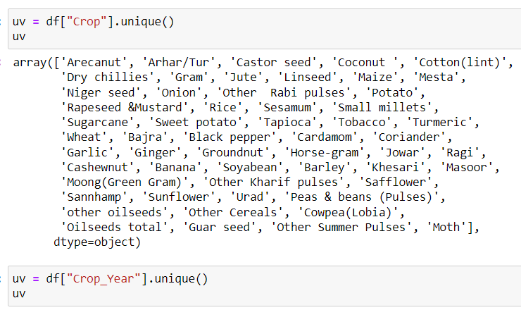

4. Feature Engineering: - Derive new features from existing ones, enhancing the model's predictive power.

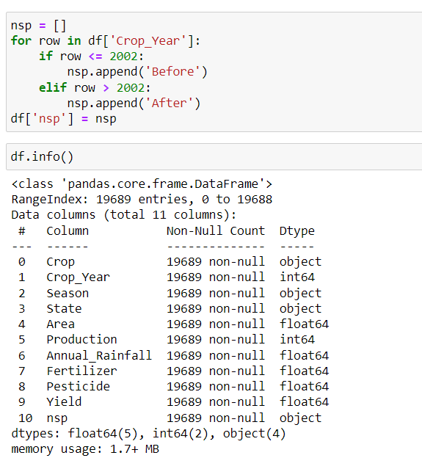

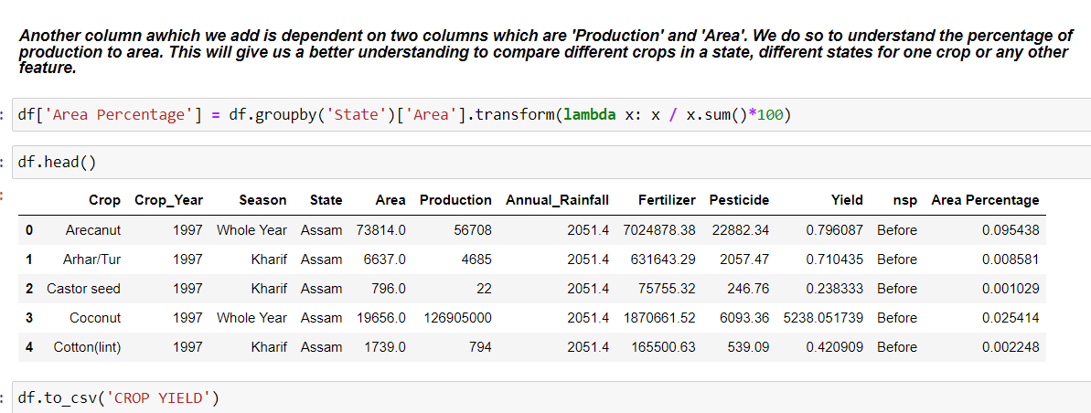

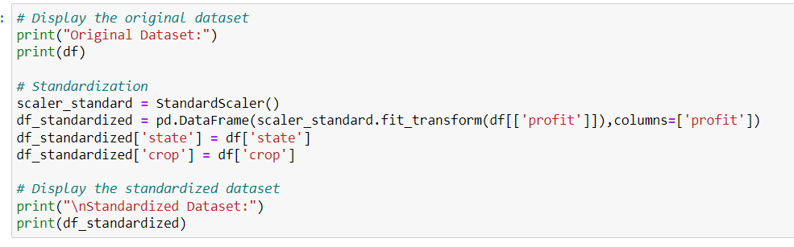

5. Machine Learning Models:

- Implement crop recommendation using supervised learning algorithms (e.g., decision trees, random forests) trained on historical data.

6. Time Series Analysis:

- Employ time series analysis on production, price, and yield data to identify trends and seasonality.

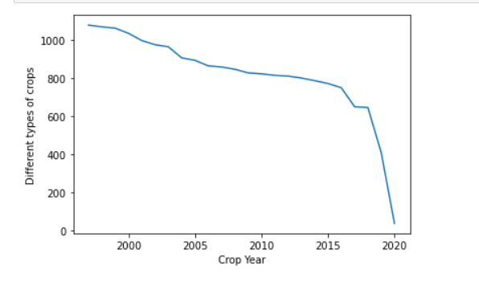

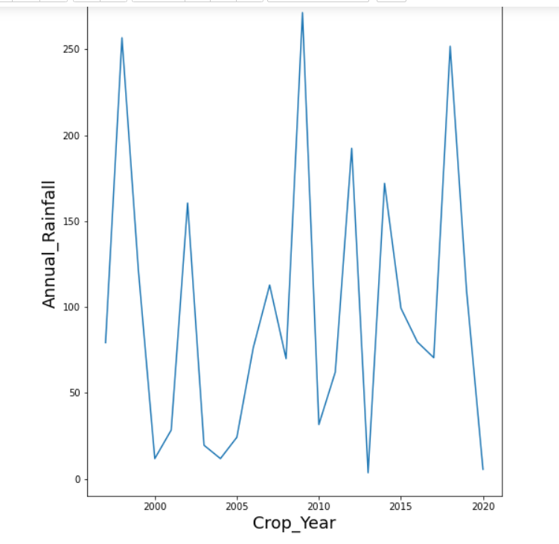

Other Visualizations:

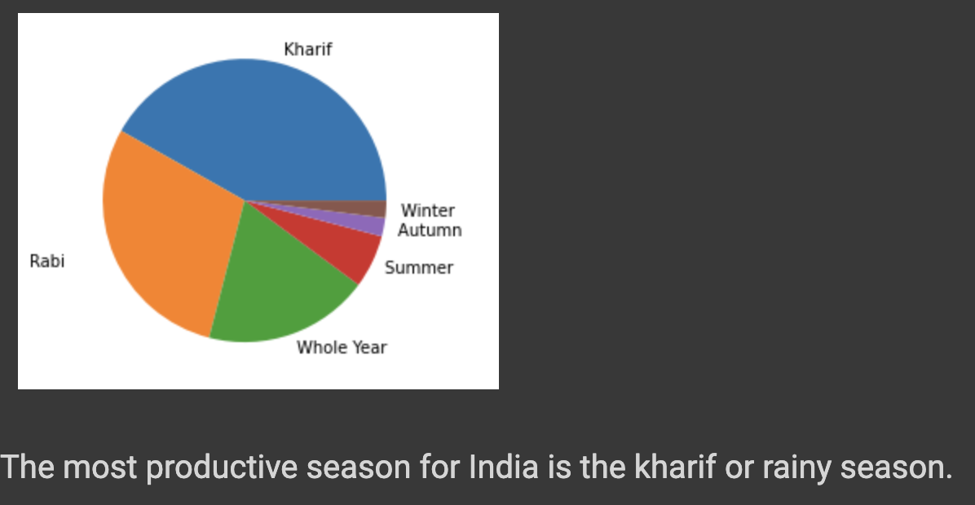

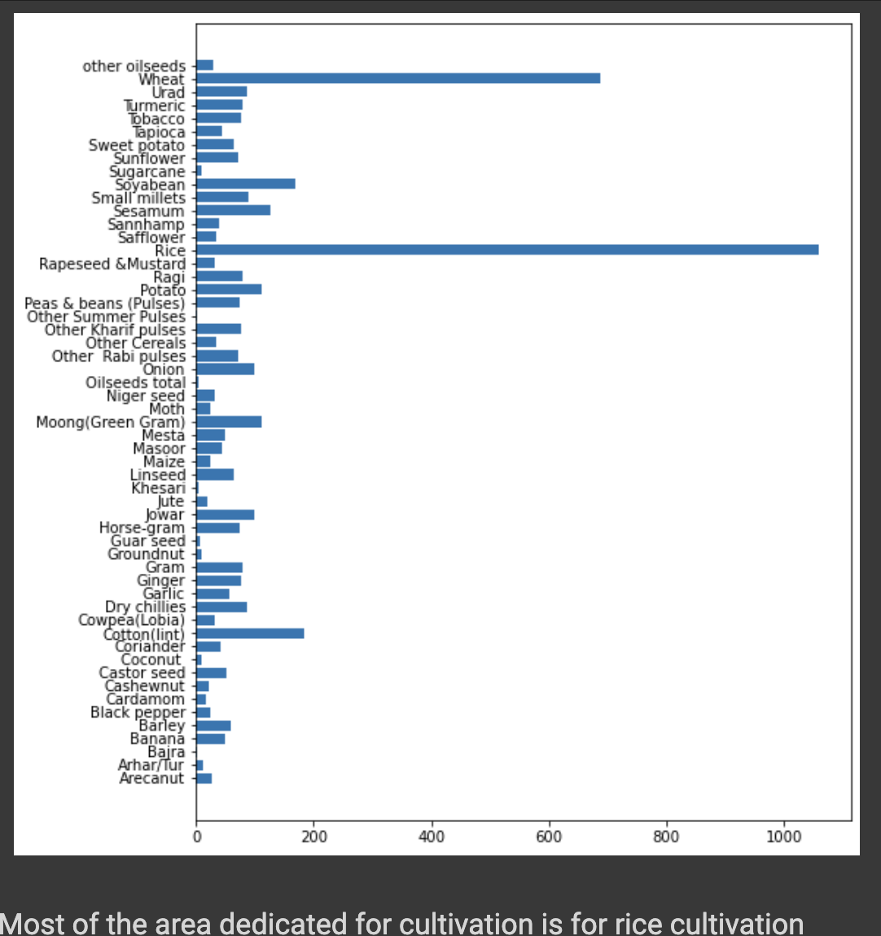

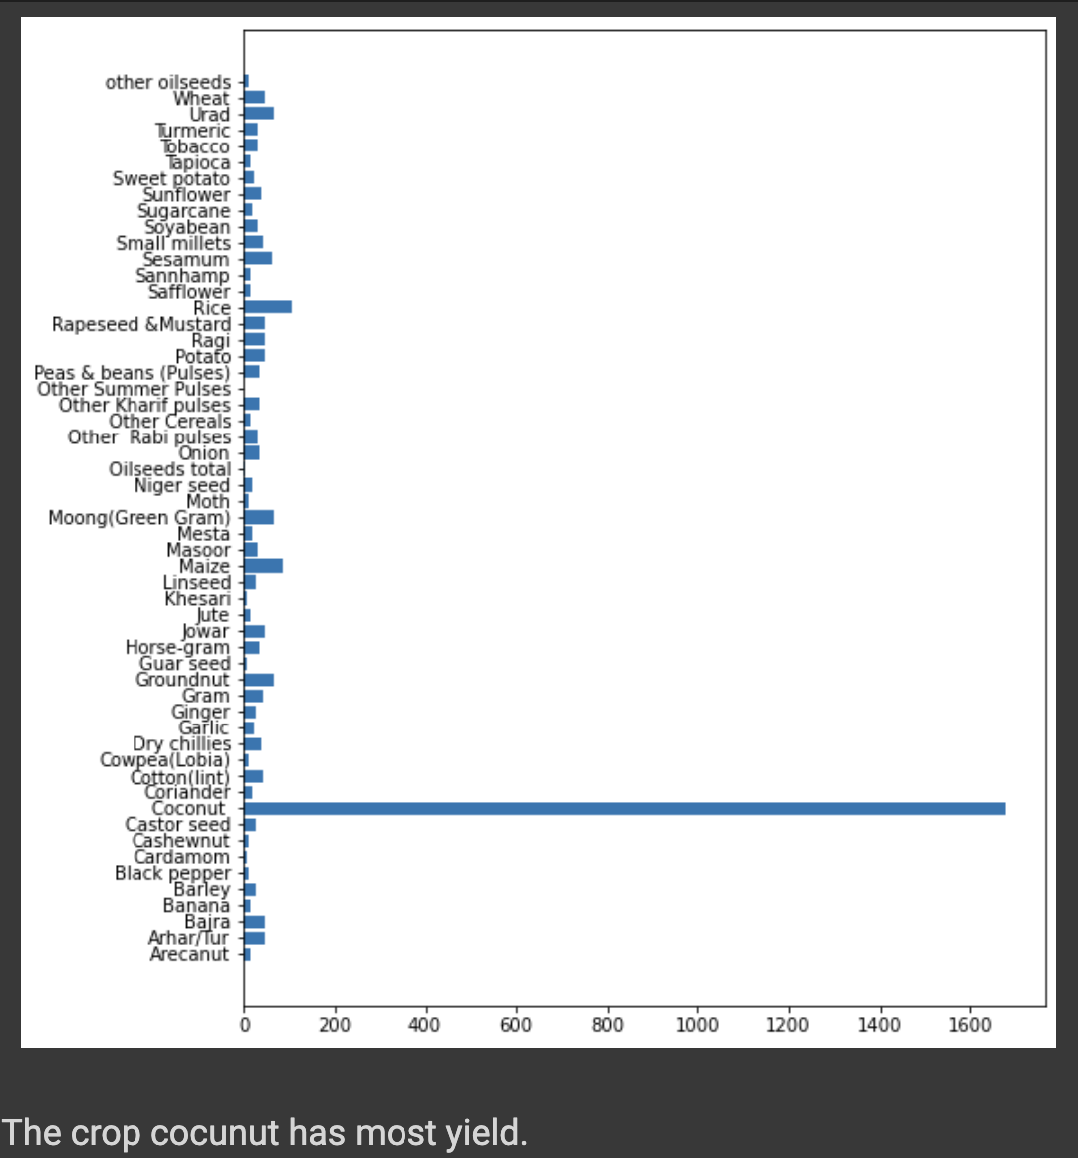

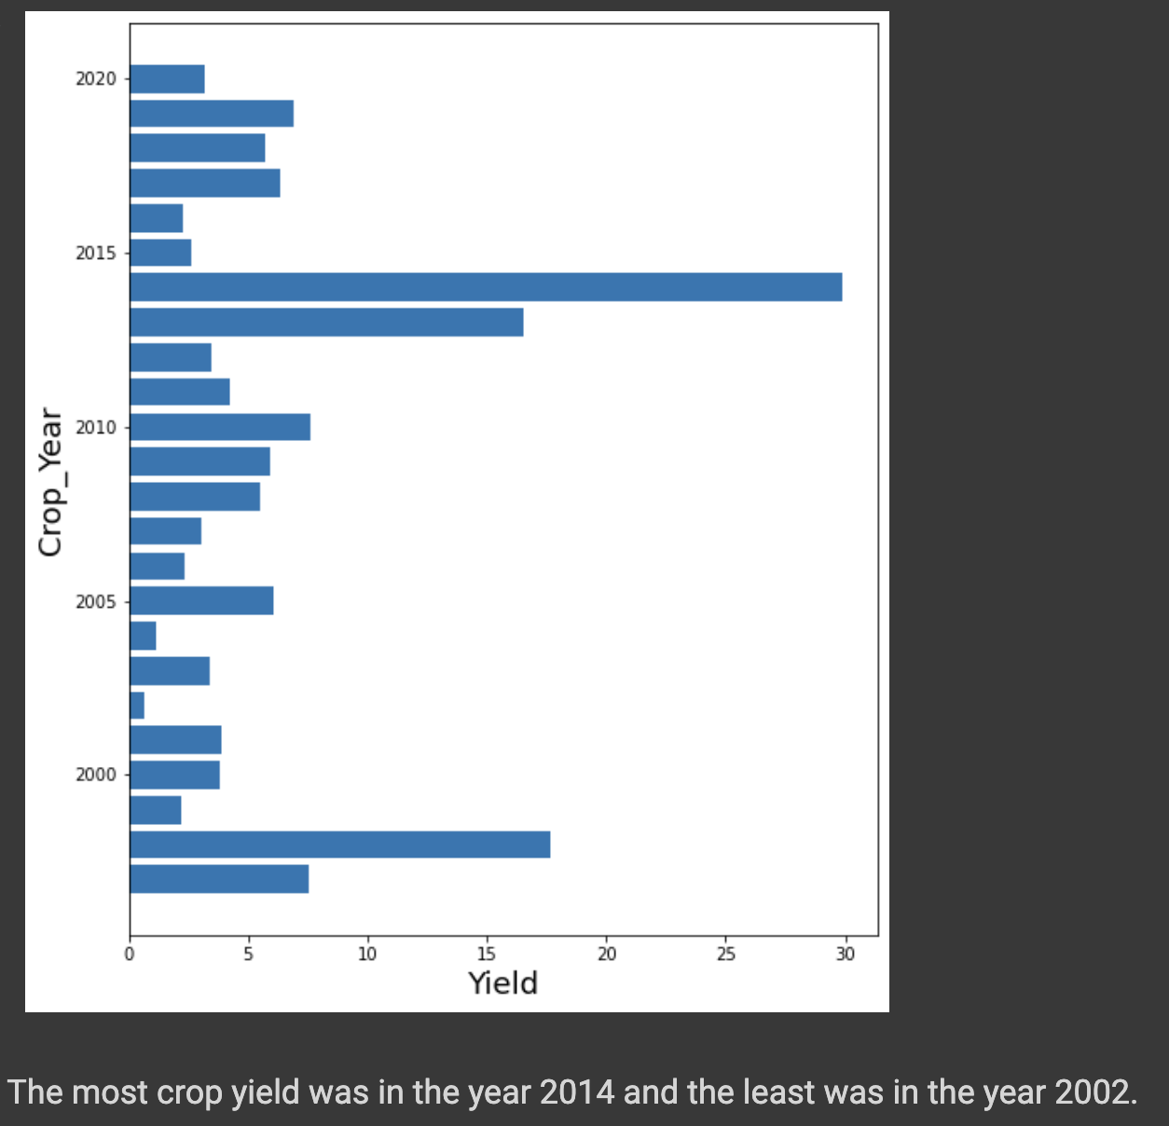

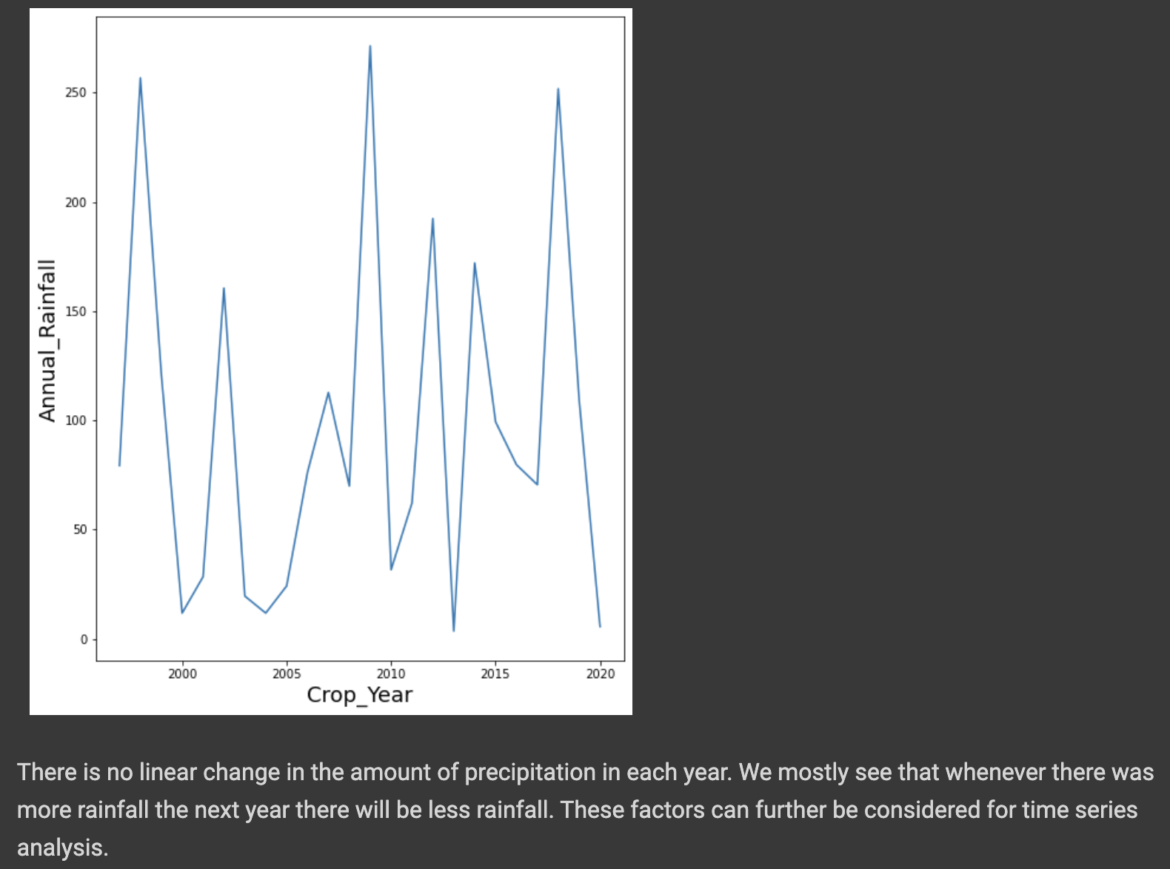

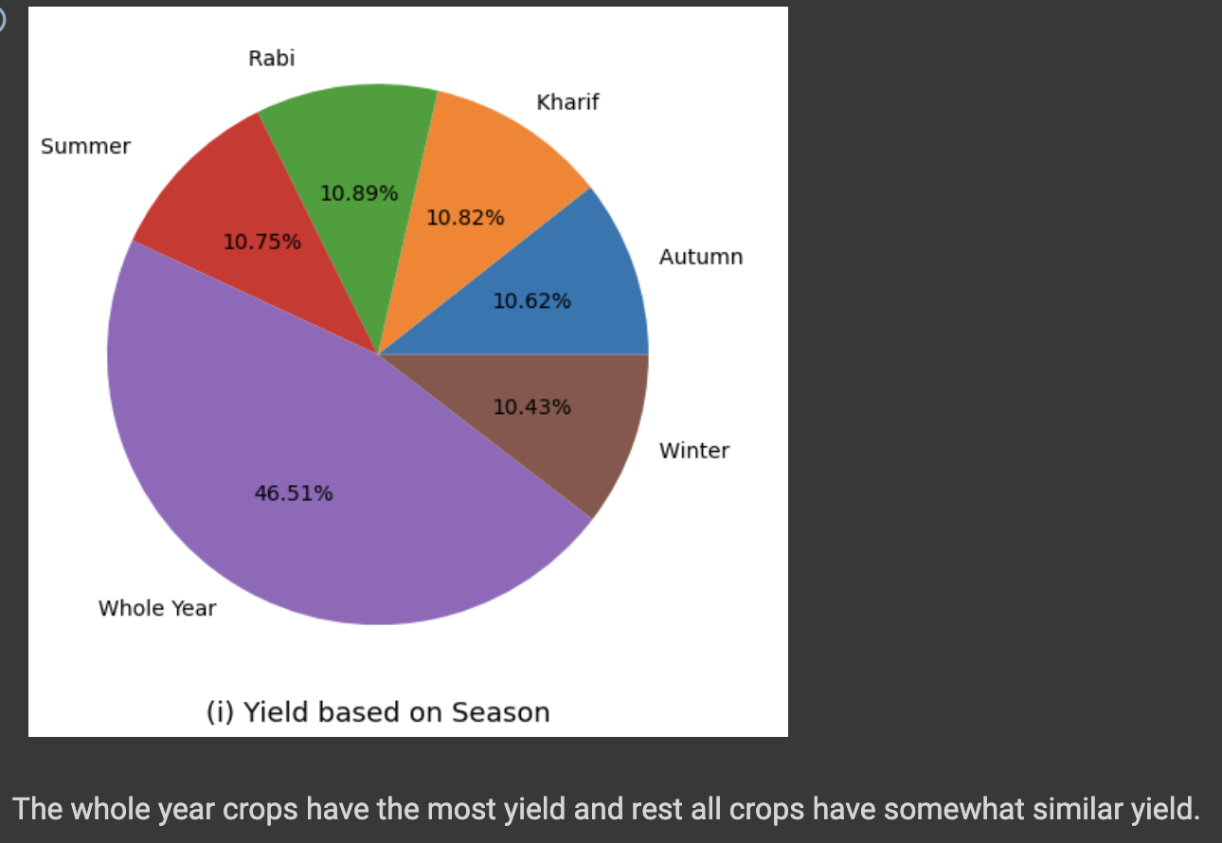

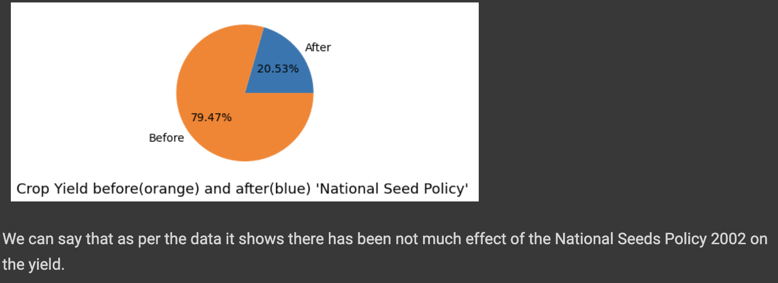

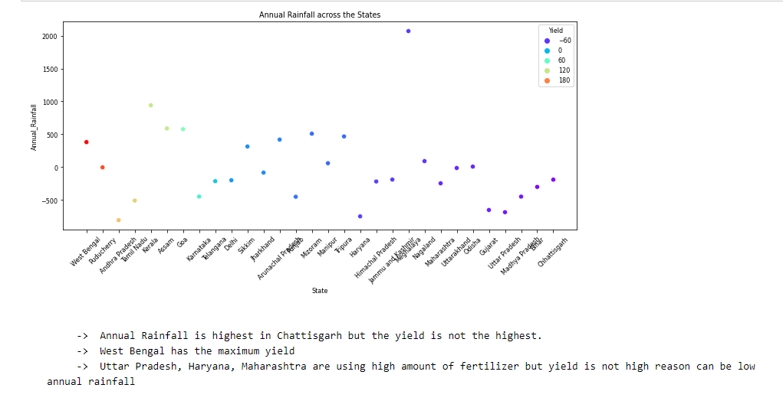

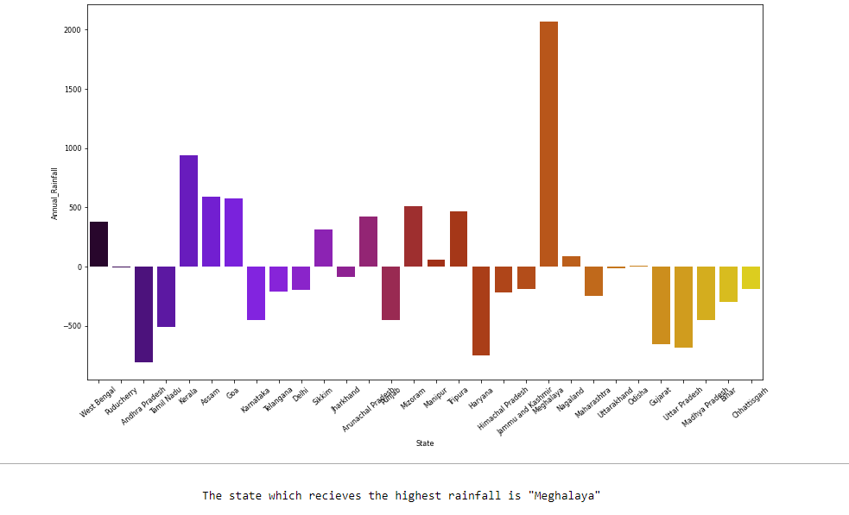

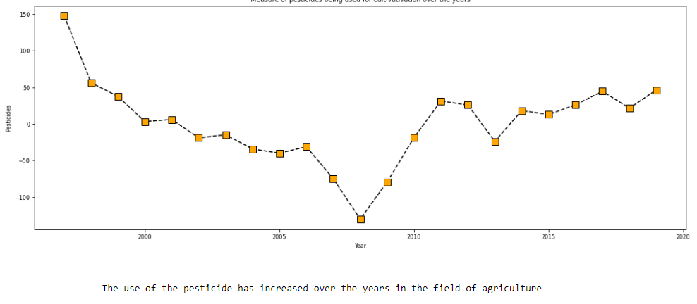

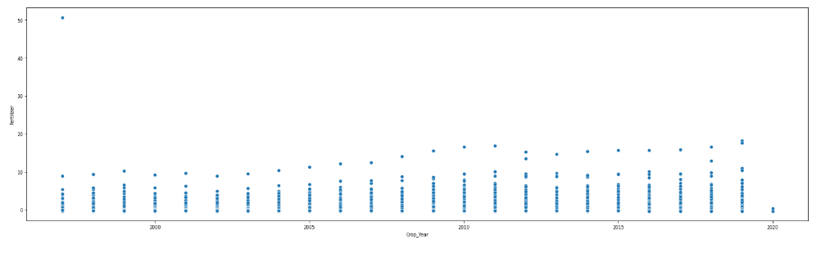

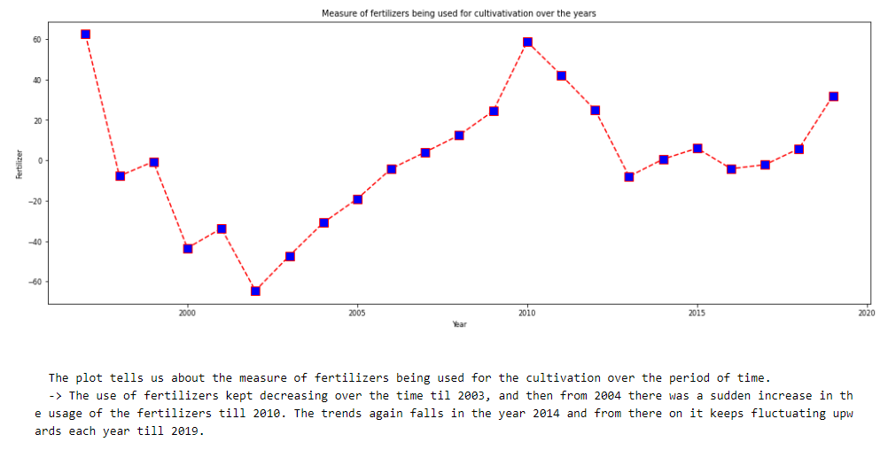

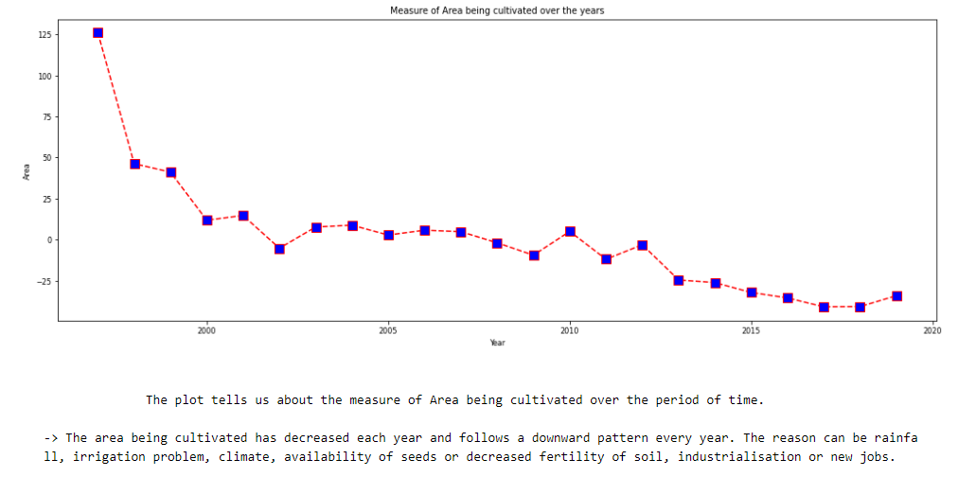

7. Dashboard Integration: - Implement a user-friendly dashboard to visualize analytics results and crop recommendations.

8. Scalability Considerations: - Design the system with scalability in mind, allowing for easy integration of additional datasets and expansion of features.

9. Data profiling - We provided a report using y-data_profiling and pandas_profiling.

